02.80 ENGAGEMENT QUALITY REVIEW – EXECUTION AND FINALISATION

The following describes the functionality and features included in Probe Audit Premium+

Objective

The objective of this document is to assist the engagement quality reviewer in performing and documenting the engagement quality review of the execution and finalisation phase of the audit engagement, including an evaluation of the significant judgments made by the engagement team and the conclusions reached.

The following key concepts of the Probe Audit Premium+ Methodology are set in this document:
- Independent evaluation of significant judgments made by the engagement team (ISQM 2)
- Assessment of whether engagement documentation supports the conclusions reached
- Completion of the engagement quality review as a prerequisite for dating the audit report

Document placement

Document 02.80 – Engagement Quality Review – Execution and finalisation can be found in the Finalisation folder in the Caseware document manager.
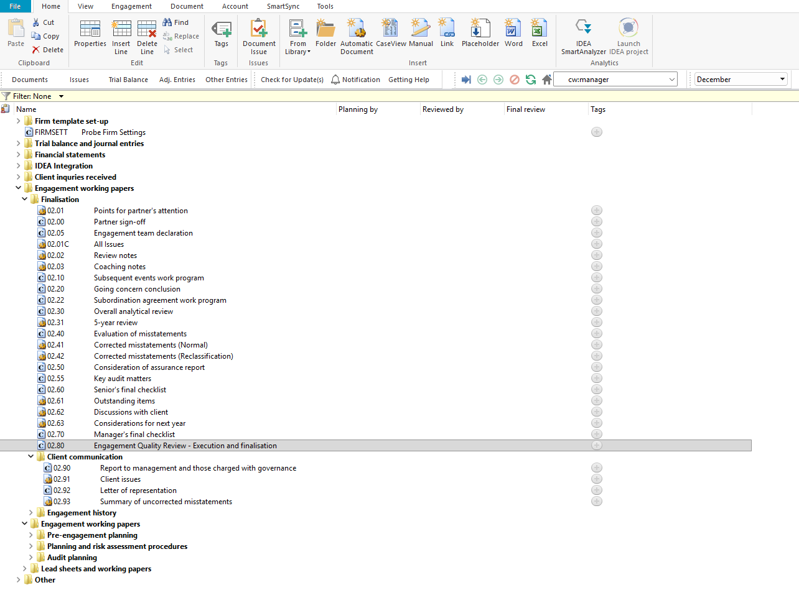

Document content

This document is designed to be a questionnaire type document with space for a comment or further description. The document addresses the requirements of ISQM 2 and ISA 220 relating to the engagement quality review of the execution and finalisation phase of the audit.

This document is divided into different bookmarks in the document map to assist you with the engagement quality review:

Significant judgments and matters

Firm mandatory – based on events and conditions present

Other responsibilities

Conclusion

Engagement quality reviewer
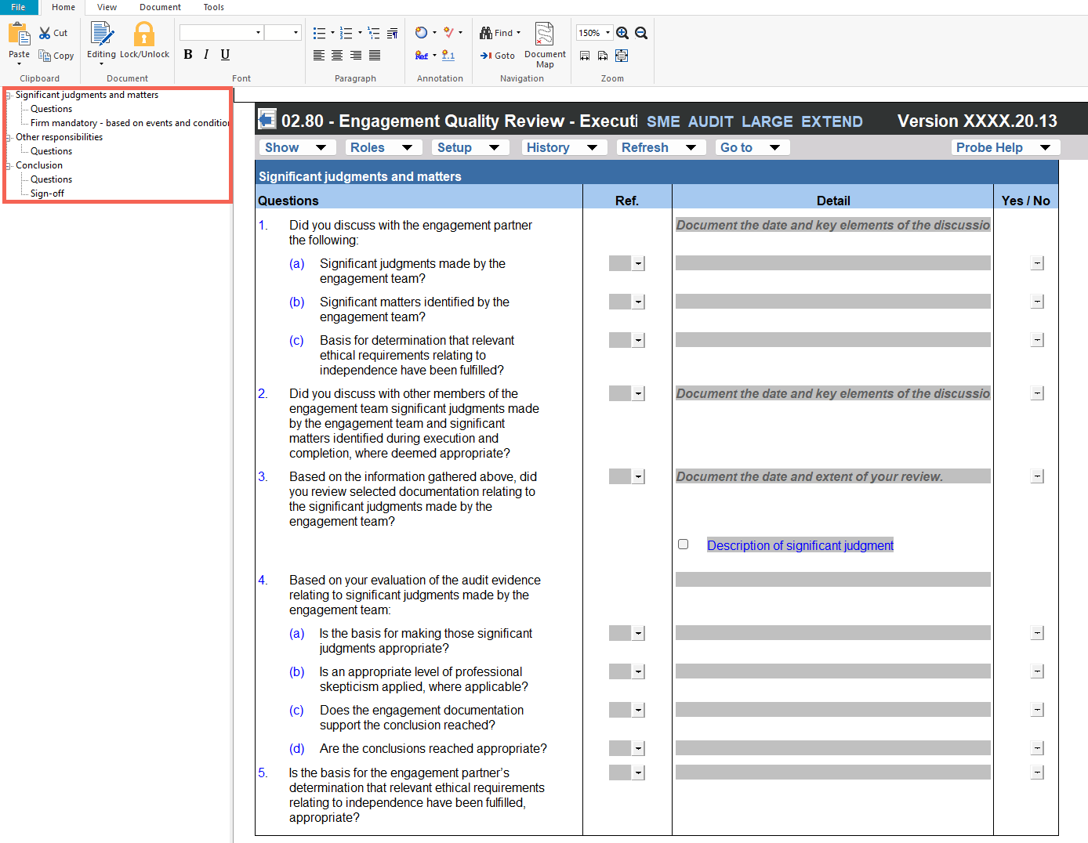

Layout
Column | Input Required | Outcome
Significant judgments and matters
Questions | The engagement quality reviewer responds to questions relating to the significant judgments made by the engagement team during the execution and finalisation phase. Questions address discussions with the engagement partner, review of documentation, and evaluation of audit evidence. | No impact on the engagement file.
Ref. | Insert a cross-reference to supporting documentation where applicable. | No impact on the engagement file.
Detail | Provide additional detail or commentary where applicable. | No impact on the engagement file.
Yes / No | Select Yes or No to respond to each question. | No impact on the engagement file.
Firm mandatory – based on events and conditions present
Tick box | Select the tick box to indicate that the firm mandatory procedures have been considered based on the events and conditions present. | No impact on the engagement file.
Ref. | Insert a cross-reference to supporting documentation where applicable. | No impact on the engagement file.
Detail | Provide additional detail or commentary where applicable. | No impact on the engagement file.
Yes / No | Select Yes or No to respond to each question. | No impact on the engagement file.
Other responsibilities
Questions | The engagement quality reviewer responds to questions relating to other responsibilities, including consultations on difficult or contentious matters, the engagement partner’s involvement, review of the draft financial statements, and review of the draft auditor’s report. | No impact on the engagement file.
Ref. | Insert a cross-reference to supporting documentation where applicable. | No impact on the engagement file.
Detail | Provide additional detail or commentary where applicable. | No impact on the engagement file.
Yes / No | Select Yes or No to respond to each question. | No impact on the engagement file.
Conclusion
Questions | The engagement quality reviewer responds to concluding questions relating to the overall engagement quality review, including eligibility, sufficiency of EQR procedures, and completeness of documentation. | No impact on the engagement file.
Ref. | Insert a cross-reference to supporting documentation where applicable. | No impact on the engagement file.
Detail | Provide additional detail or commentary where applicable. | No impact on the engagement file.
Yes / No | Select Yes or No to respond to each question. | No impact on the engagement file.
Engagement quality reviewer
Comment | Provide a comment on the overall engagement quality review performed. | No impact on the engagement file.
Name | Enter the name of the engagement quality reviewer. | No impact on the engagement file.
Signature | Sign to confirm the engagement quality review has been completed. | No impact on the engagement file.
Date | Enter the date on which the engagement quality review was completed. | No impact on the engagement file.

Document outcomes

The Significant judgments and matters section requires the engagement quality reviewer to evaluate whether the significant judgments made by the engagement team during the execution and finalisation phase are appropriate, including an assessment of professional skepticism applied and whether the engagement documentation supports the conclusions reached.

The Firm mandatory section provides a tick box for the engagement quality reviewer to confirm that firm mandatory procedures have been considered based on the events and conditions present.

The Other responsibilities section requires the engagement quality reviewer to evaluate consultations on difficult or contentious matters, the engagement partner’s involvement, the draft financial statements, and the draft auditor’s report.

The Conclusion section requires the engagement quality reviewer to confirm that the EQR procedures performed provide a sufficient basis for an objective evaluation, that no circumstances impair eligibility, and that the documentation of the EQR is complete.

The Engagement quality reviewer section provides a sign-off block where the reviewer records a comment, name, signature, and date to confirm completion of the engagement quality review.

Group Audits

When the engagement type was selected as ‘Group Audit Single’ or ‘Group Audit Multiple’, questions are modified for the separate group audit engagement file.

Additional questions were added for group audit engagement to:

Identify components for planning and performing of audit procedures;

Determine expected involvement of component auditors in risk assessment procedures and further audit procedures;

Evaluate access to components and component auditors; and

Determine whether there is any indication that the group auditor will not be able to be sufficiently and appropriately involved in the work of the component auditor.

Some questions include red warnings or blue text in the description column. Follow the red warnings that inform you where key information should be recorded and the blue text in the description column that advises you where the understanding may be documented.

IN CONCLUSION

Features

The following features are available in the document:

Insert or delete a comment, see page F3

Guidance, see page F16

Freeze, see page F19

